Motor for Driverless Vehicle Prototype

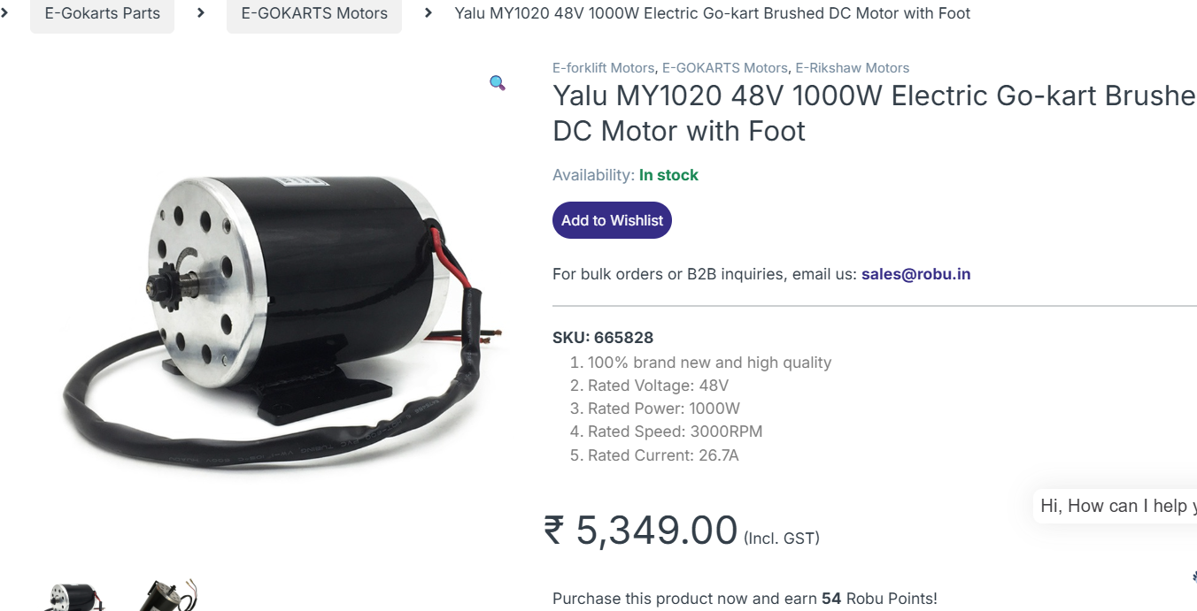
Option 1:
Name: YALU MY1020
Price: Rs 6000
Rated voltage: 48V
Rated power: 1000W
Rated speed: 3000RPM
Rated Current: 27A
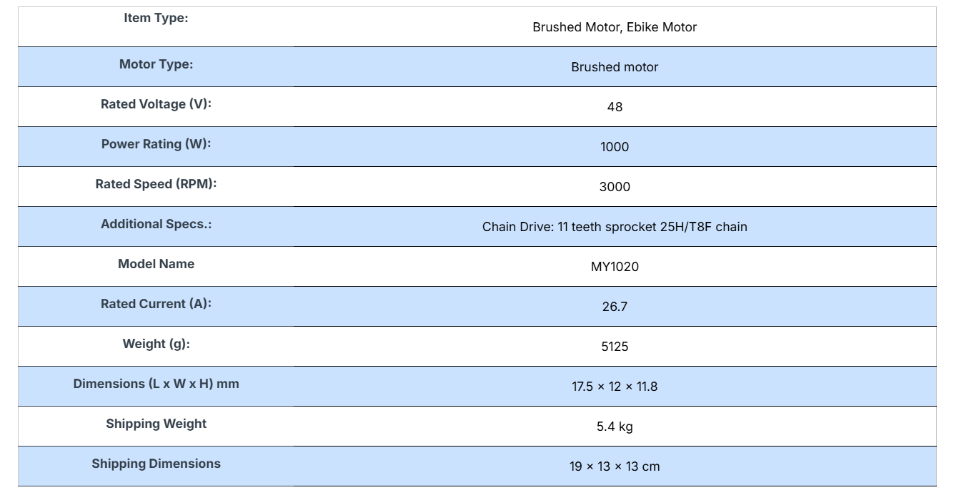
Rated torque: 3Nm

**SUITABLE MOTOR CONTROLLER AVAILABLE**

Link for motor: https://robu.in/product/my1020-48v-1000w-electric-go-kart-brushed-dc-motor-with-foot/#tab-specification
Link for controller: https://robu.in/product/brushless-controller-for-1000w48v-bldc-motor/
Datasheet: https://robu.in/wp-content/uploads/2022/05/Wenzhou-Yalu-DC-Motor-MY1020Z-1265090.pdf
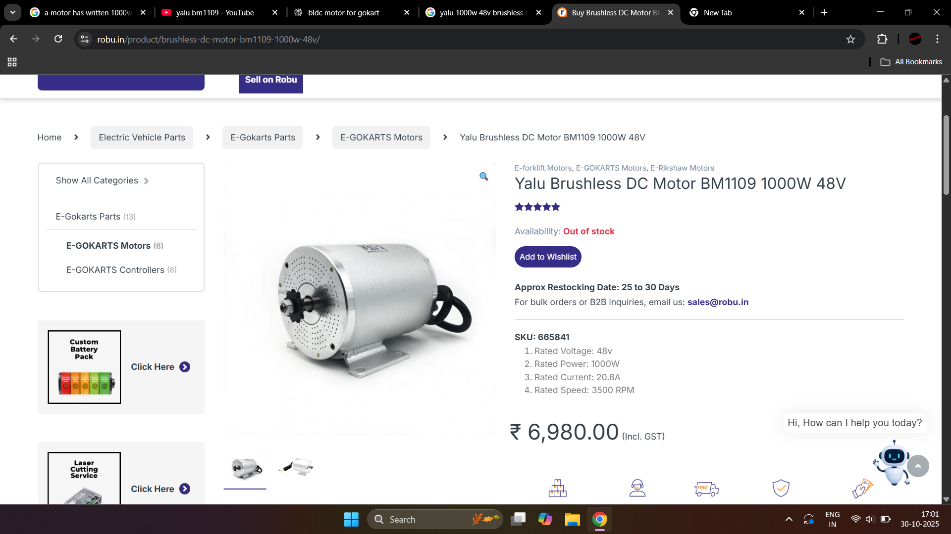
Option 2:
Name: YALU BM1109
Price: Rs 7000
Rated Voltage: 48v
Rated Power: 1000W
Rated Current: 20.8A
Rated Speed: 3500 RPM
Rated torque: 3.5 Nm

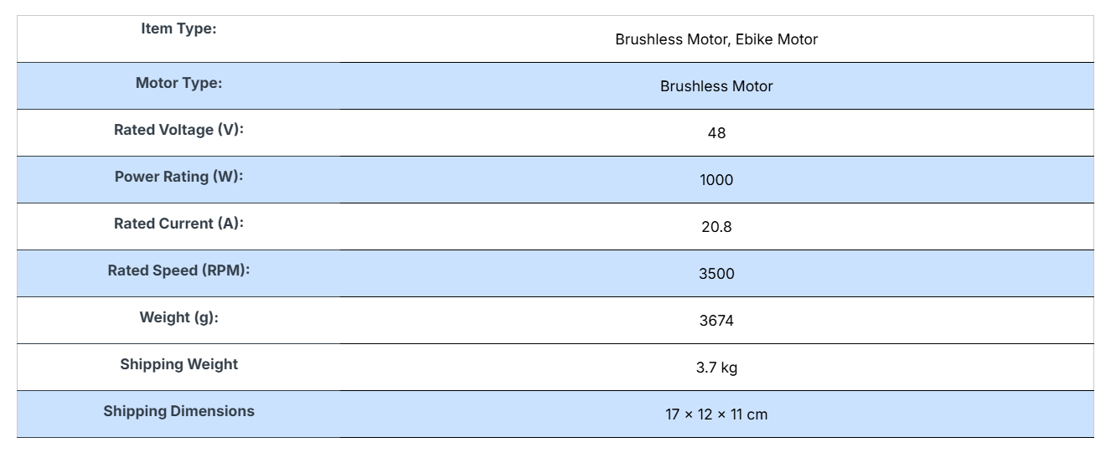
**SUITABLE MOTOR CONTROLLER AVAILABLE**

Link for motor: https://robu.in/product/brushless-dc-motor-bm1109-1000w-48v/#tab-specification
Link for controller: https://robu.in/product/motor-controller-48v-for-bm1109-1000w/
Link for Datasheet: https://www.scribd.com/document/843724674/YALU-MOTOR-BM1109-removed

Option 3:
Borrowed by electrical department (suggested by Mukul)
Rated Voltage: 48V BLDC
Rated power: 400W
Rated speed: 3000rpm
Rated torque: 1.3 Nm

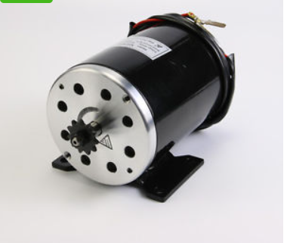
Option 4:
Name: Yalu MY1020
Price: Rs 5000
Supply Voltage: 24v.
Current Draw (Rated): 27.4A.
Current Draw (No Load): 2.5A.
Rated (constant) Torque: 190 N-cm.
Speed: 2500 RPM.
Efficiency: Greater than 75%.
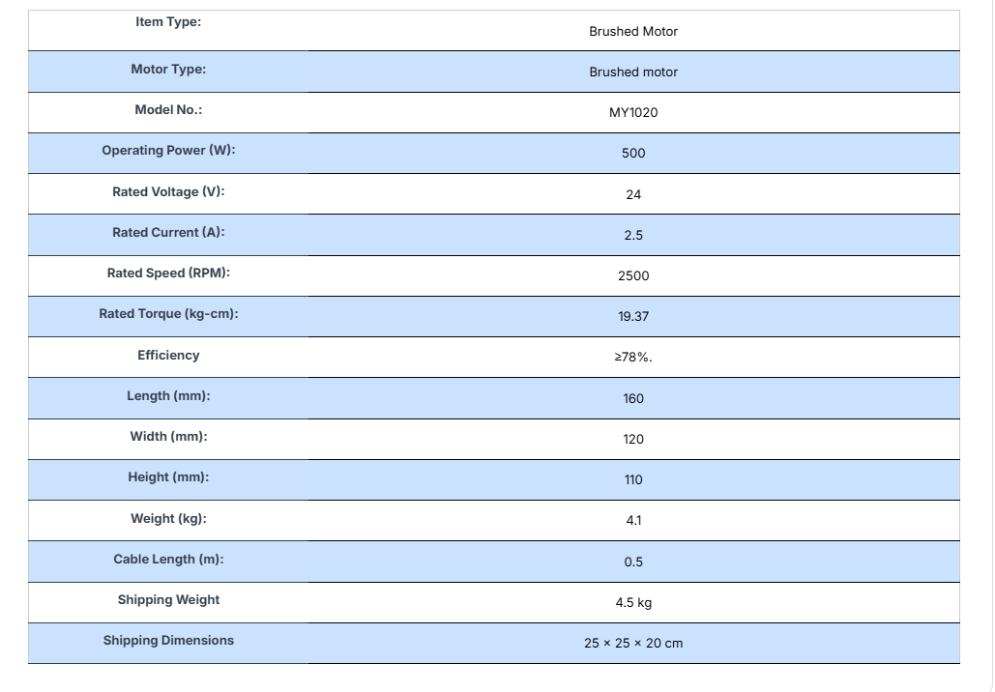
Weight: 4.10 Kg.

**SUITABLE MOTOR CONTROLLER AVAILABLE**
Link for motor: https://robu.in/product/500w-24v-dc-2500-rpm-for-scooter-bike-go-kart-minibike-e-atv-my1020/#tab-description
Link for controller: https://robu.in/product/motor-controller-24v-500w-my1020-diy-electric-bicycle-kit/
Datasheet: https://robu.in/wp-content/uploads/2022/05/Wenzhou-Yalu-DC-Motor-MY1020Z-1265090.pdf

